Object Oriented Programming, Group C Assignment No.8

Steps:
1.Create a Database employee_db in MySQL using following queries

CREATE DATABASE employee_db;
USE employee_db;

2.Create Tables In Database
CREATE TABLE employees (
id SERIAL PRIMARY KEY,
name VARCHAR(100) NOT NULL,
department VARCHAR(100),
salary DECIMAL(10,2),
email VARCHAR(100) UNIQUE,
created_at TIMESTAMP DEFAULT CURRENT_TIMESTAMP
);

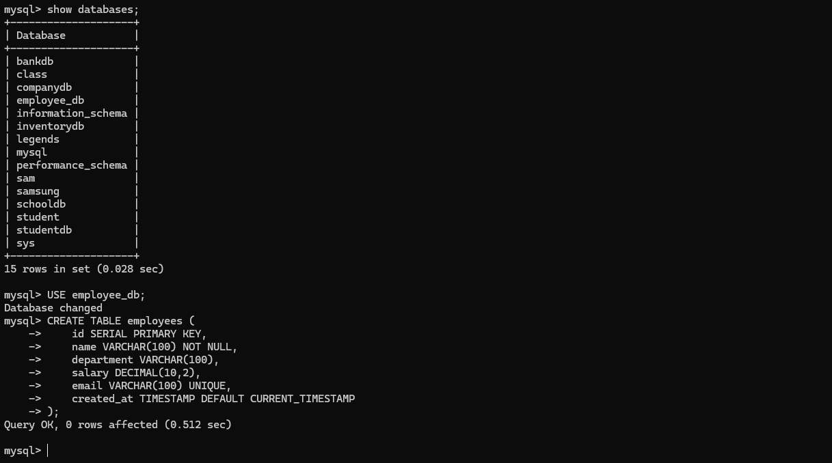

3.Download JDBC Driver
https://dev.mysql.com/downloads/connector/j/
MySQL → mysql-connector-j

4.Write a following JAVA code

// Source code is decompiled from a .class file using FernFlower decompiler (from Intellij IDEA).
import java.io.PrintStream;
import java.sql.Connection;
import java.sql.DriverManager;
import java.sql.PreparedStatement;
import java.sql.ResultSet;
import java.util.Scanner;

public class EmployeeManagement {
static final String URL = "jdbc:mysql://localhost:3306/companydb?useSSL=false&allowPublicKeyRetrieval=true";
static final String USER = "root";
static final String PASSWORD = "avcoe";

public EmployeeManagement() {
}

public static void main(String[] var0) {
try {
Class.forName("com.mysql.cj.jdbc.Driver");
Connection var1 = DriverManager.getConnection("jdbc:mysql://localhost:3306/companydb?useSSL=false&allowPublicKeyRetrieval=true", "root", "avcoe");
Scanner var2 = new Scanner(System.in);
System.out.println("Connected Successfully!\n");

while(true) {
System.out.println("===== EMPLOYEE MANAGEMENT =====");
System.out.println("1. Add Employee");
System.out.println("2. View Employees");
System.out.println("3. Update Employee");
System.out.println("4. Delete Employee");
System.out.println("5. Exit");
System.out.print("Choose: ");
int var3 = var2.nextInt();
switch (var3) {
case 1:
var2.nextLine();
System.out.print("Enter Name: ");
String var4 = var2.nextLine();
System.out.print("Enter Salary: ");
double var5 = var2.nextDouble();
PreparedStatement var7 = var1.prepareStatement("INSERT INTO employees (name, salary) VALUES (?, ?)");
var7.setString(1, var4);
var7.setDouble(2, var5);
var7.executeUpdate();
System.out.println("Employee Added!\n");
break;
case 2:
ResultSet var8 = var1.createStatement().executeQuery("SELECT * FROM employees");
System.out.println("\nID | Name | Salary");
System.out.println("---------------------");

while(var8.next()) {
PrintStream var10000 = System.out;
int var10001 = var8.getInt("id");
var10000.println(var10001 + " | " + var8.getString("name") + " | " + var8.getDouble("salary"));
}

System.out.println();
break;
case 3:
System.out.print("Enter Employee ID to Update: ");
int var9 = var2.nextInt();
System.out.print("Enter New Salary: ");
double var10 = var2.nextDouble();
PreparedStatement var12 = var1.prepareStatement("UPDATE employees SET salary=? WHERE id=?");
var12.setDouble(1, var10);
var12.setInt(2, var9);
int var13 = var12.executeUpdate();
if (var13 > 0) {
System.out.println("Employee Updated Successfully!\n");
} else {
System.out.println("Employee Not Found!\n");
}
break;
case 4:
System.out.print("Enter Employee ID to Delete: ");
int var14 = var2.nextInt();
PreparedStatement var15 = var1.prepareStatement("DELETE FROM employees WHERE id=?");
var15.setInt(1, var14);
int var16 = var15.executeUpdate();
if (var16 > 0) {
System.out.println("Employee Deleted Successfully!\n");
} else {
System.out.println("Employee Not Found!\n");
}
break;
case 5:
System.out.println("Exiting Program...");
var1.close();
var2.close();
return;
default:
System.out.println("Invalid Choice!\n");
}
}
} catch (Exception var17) {
System.out.println("Database Error: " + var17.getMessage());
}
}
}

5.Save This code in Employee Management folder
For Connecting The JAVA code to the MySQL Database using MySQL jar file put MySQL jar file in same folder where the JAVA code is in "lib" file

6.Executing the JAVA code
Run the JAVA code using Visual Studio Code

Output:
1. Add Employee
2. View Employees
3. Update Employee
4. Delete Employee
5. Exit

7.Execute Above Operations one by one for inserting values in database

for example:

===== EMPLOYEE MANAGEMENT =====
1. Add Employee
2. View Employees
3. Update Employee
4. Delete Employee
5. Exit
Choose: 1
Enter Name: Harry
Enter Salary: 100000
Employee Added!

===== EMPLOYEE MANAGEMENT =====
1. Add Employee
2. View Employees
3. Update Employee
4. Delete Employee
5. Exit
Choose: 2
Harry | 100000.0

===== EMPLOYEE MANAGEMENT =====
1. Add Employee
2. View Employees
3. Update Employee
4. Delete Employee
5. Exit
Choose: 3
Enter Employee ID to Update: 1
Enter New Salary: 200000
Employee Updated Successfully!

===== EMPLOYEE MANAGEMENT =====
1. Add Employee
2. View Employees
3. Update Employee
4. Delete Employee
5. Exit
Choose: 4
Enter Employee ID to Delete: 1
Employee Deleted Successfully!

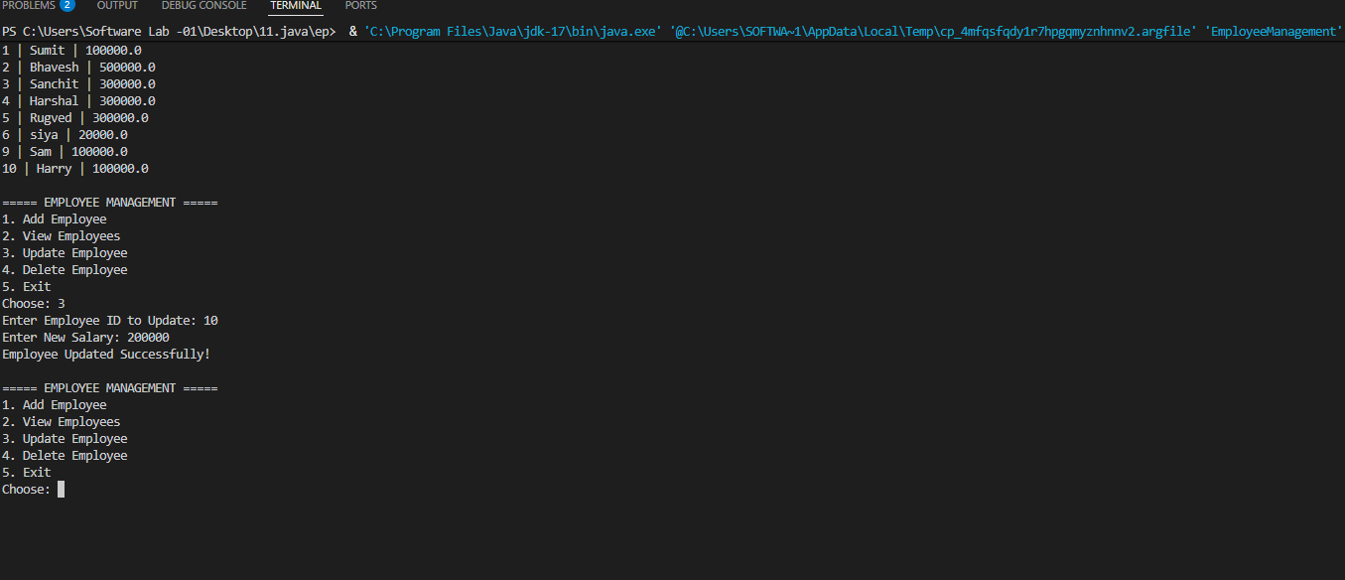

8. In MySQL check for the inserte data using following queries
SHOW DATABASES;

USE employee_db;

SHOW TABLES;

SELECT * FROM employees;

